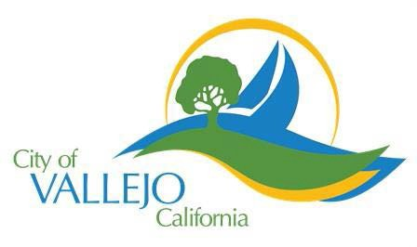

Vallejo Municipal Marina - 42 Harbor Way – Vallejo – California – 94590 (707) 648-4370

COMPLETED WORK FROM MAY 2018-JULY 2018

- Redecking of B dock.

- Painted J & K docks entryway.

- Painted Fuel Dock house.

