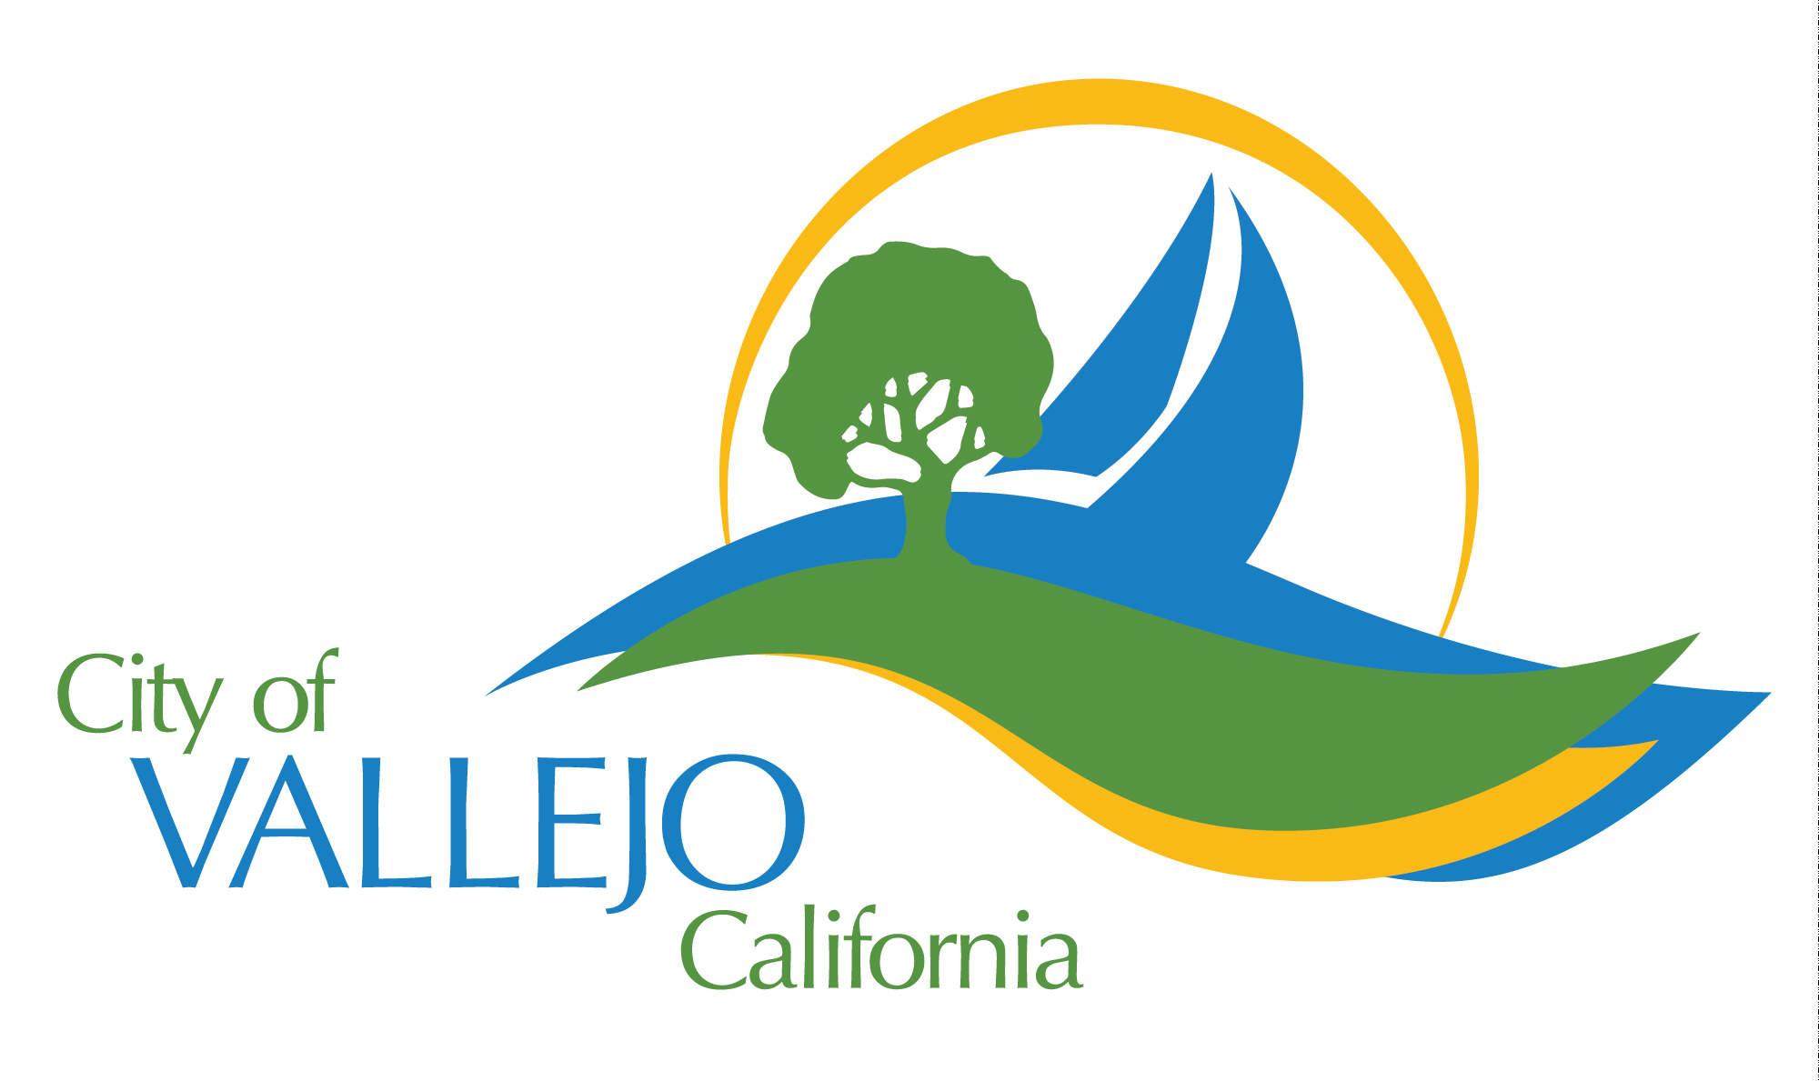

Public Works Maintenance Division ∙ 111 Amador Street ∙ Vallejo ∙ CA ∙ 94590

Vallejo Waterfront – Marina Agenda
Monday, April 30, 2018
1:00 p.m.

- Recent Discussions with Joe Callahan Regarding Parcel A & Waterfront Development
- Utility Easements (or Lack thereof)
- Locating existing utilities (phone, cable and gas/electric services to existing buildings from mainline)
- ADA issues with existing Buildings
- Parking Lot K Restroom Relocation
- Who is looking at the condition of the existing buildings and how these buildings will tie into the Waterfront Plan?

- Sardine Can
- ADA Lawsuit Status Update
- Lease update
- Overall Building Condition

- #7 Harbor Way (Old Harbor Master Building/Marine Restrooms
- Building Condition
- Bathroom Upgrade to ADA and mold and dry rot remediation
- Leasing of 2nd Floor Conference Room

- K Dock Restrooms
- Waterfront Restroom Public Access vs. Marina Access
- Need for Showers

- Marina Advisory Committee (MAC)
- Motion filed to increase Live-aboard Occupancy 5% - 10%
- Inquiries about #7 Harbor Way 2nd Floor

- Possibilities of Public/Private Partnership
- Timing with Callahan’s Development Design and Coordination
- Legalities and potential issues with State Lands

